

soen ice task 3

Software Engineering



September 13, 2023

Varsity college

[Company address]

**Table of Contents**

Model 1 :Context Model Diagram 2

Model 2 : Activity Diagram 4

Model 3 : Use Case Diagram 4

Model 4 : Sequence Diagram 5

Model 5 : Class Diagram 6

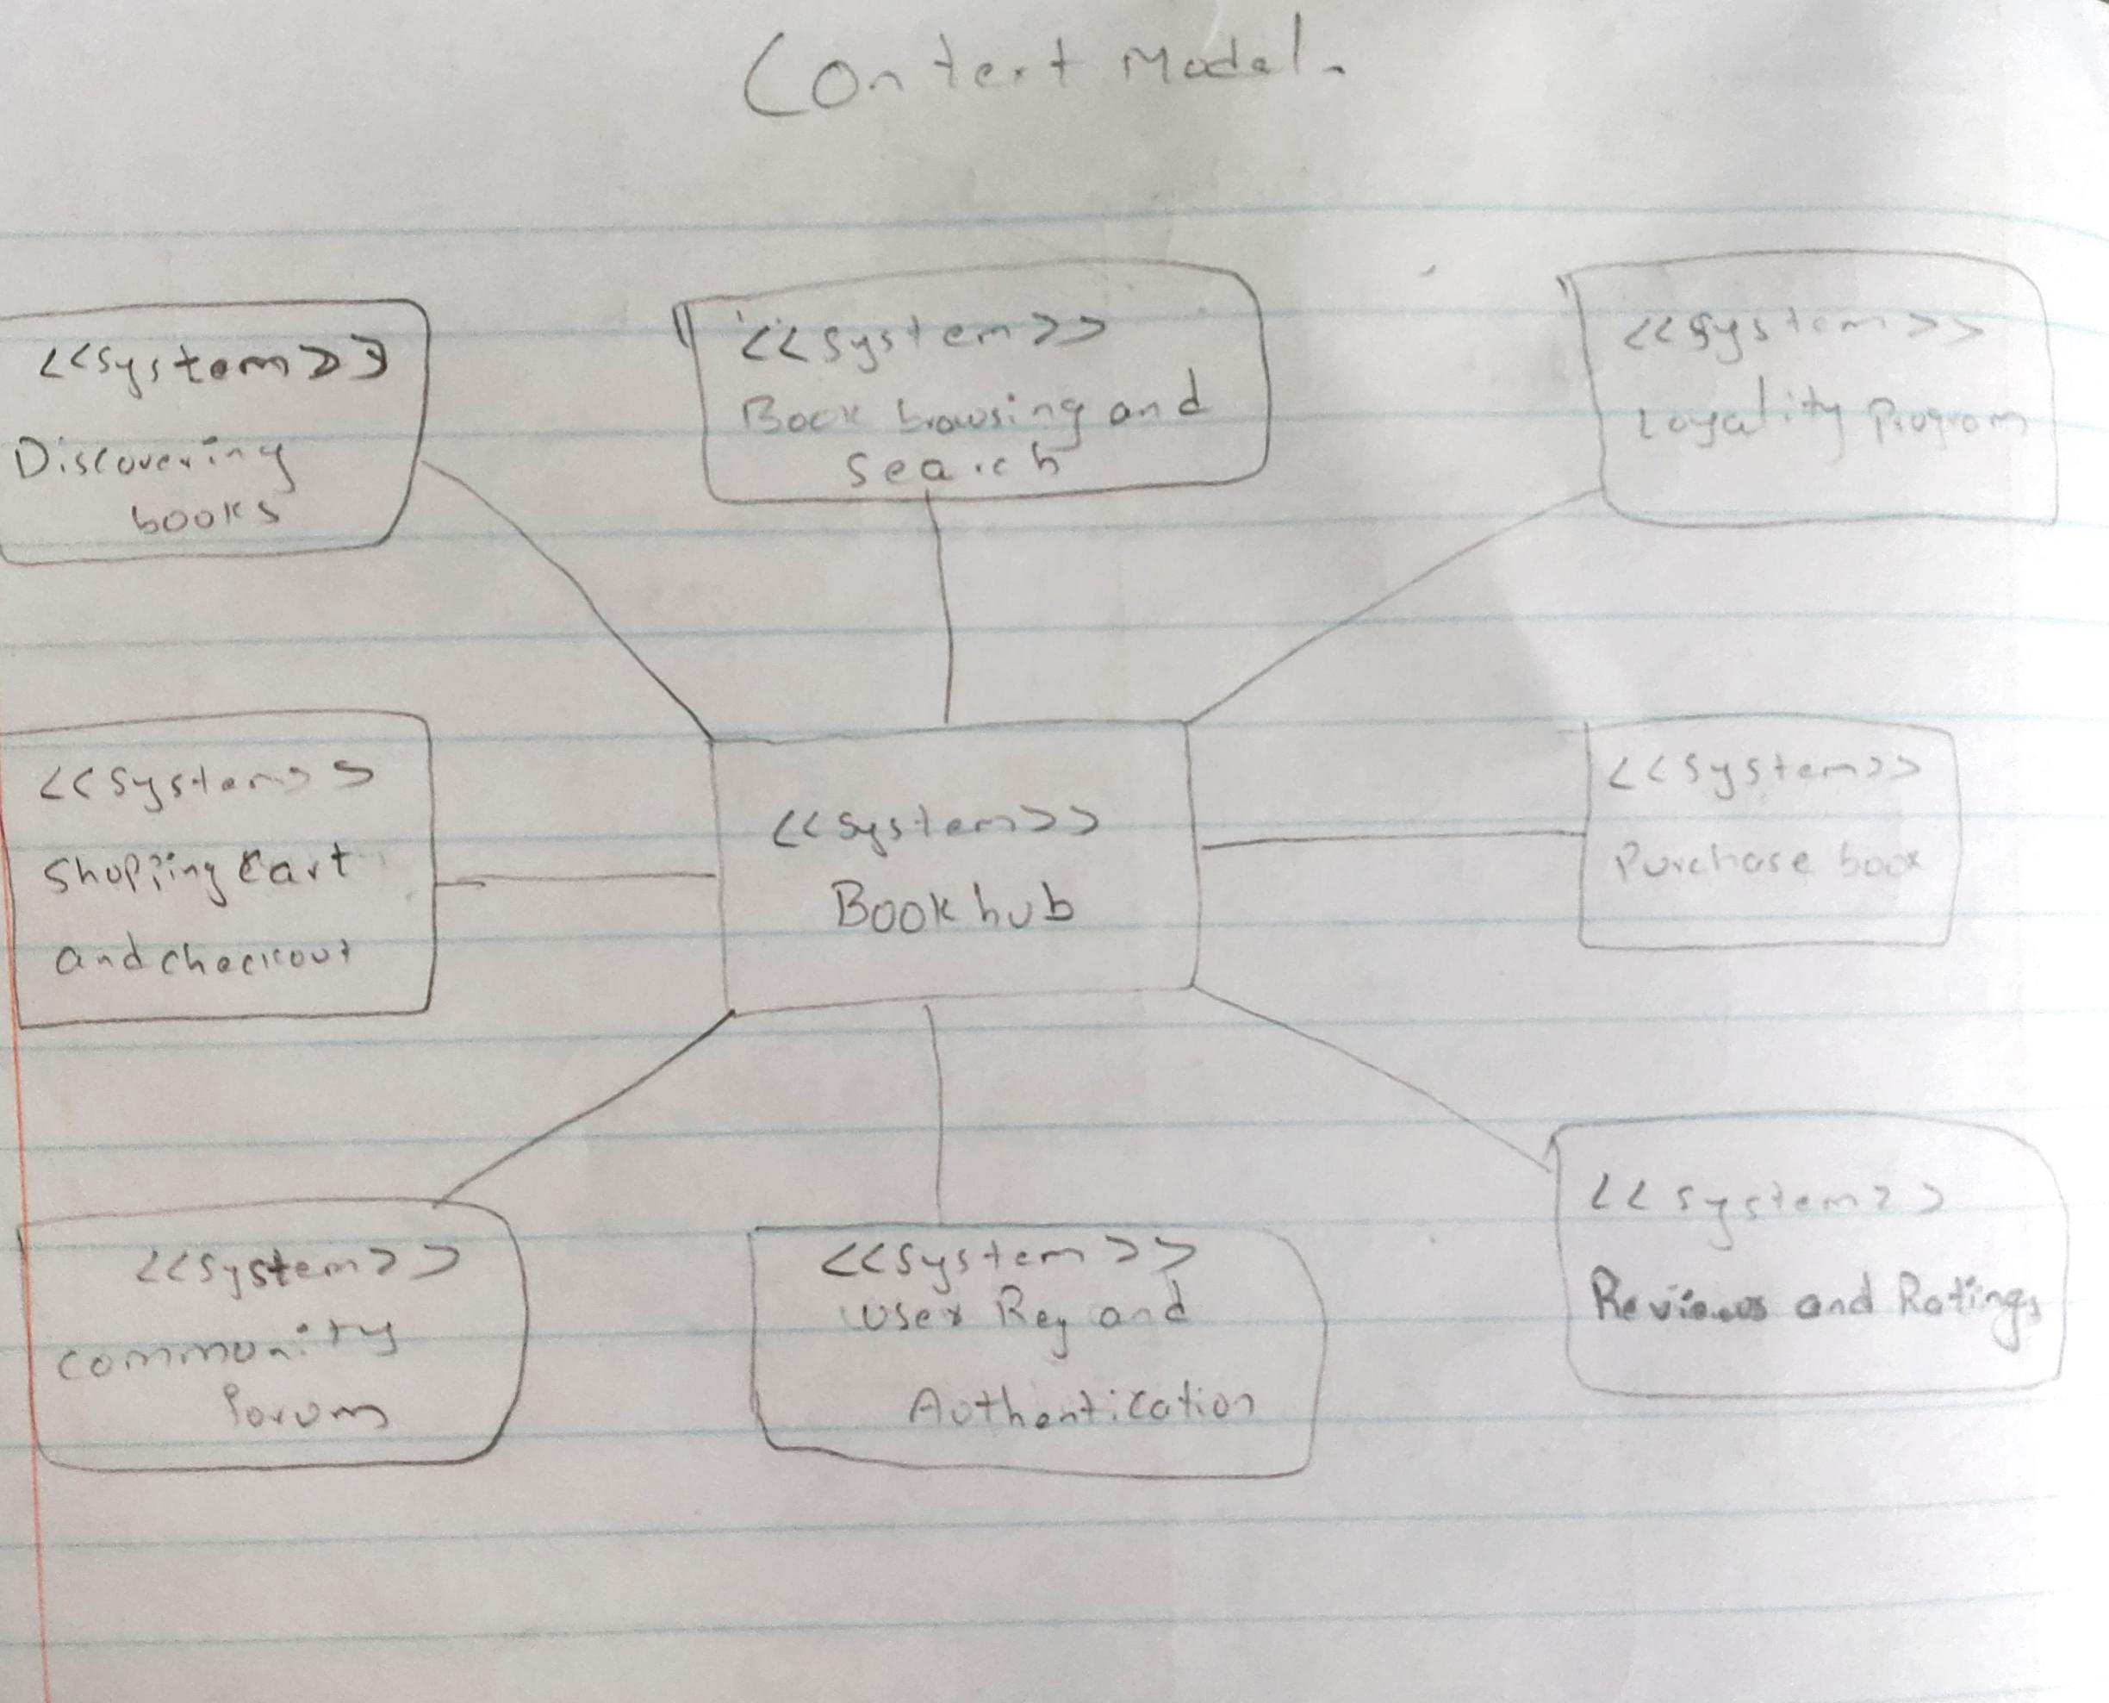

Model :Context Model Diagram

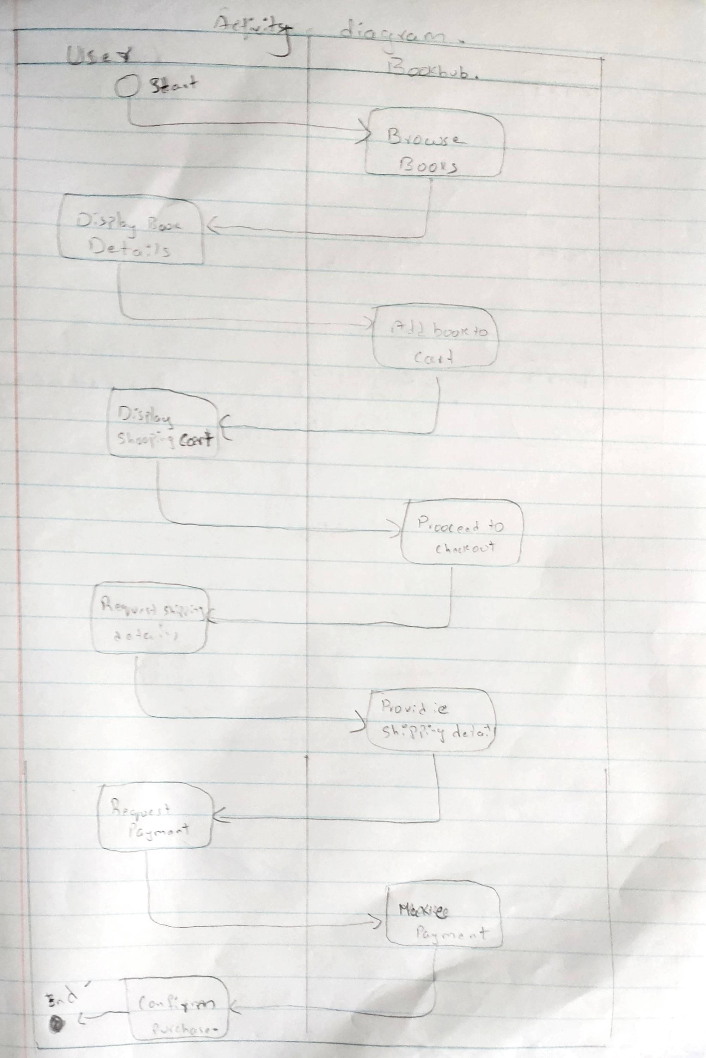

Model : Activity Diagram

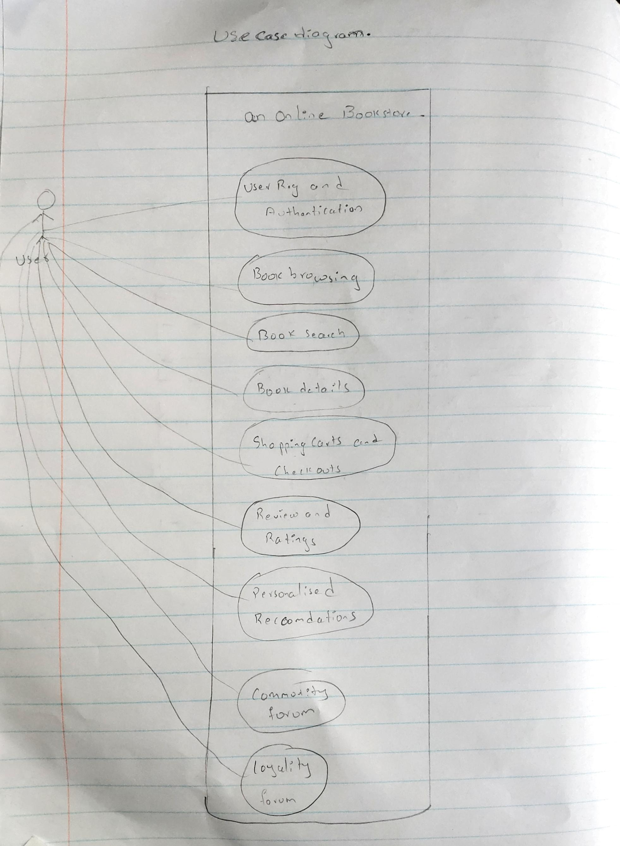

Model : Use Case Diagram

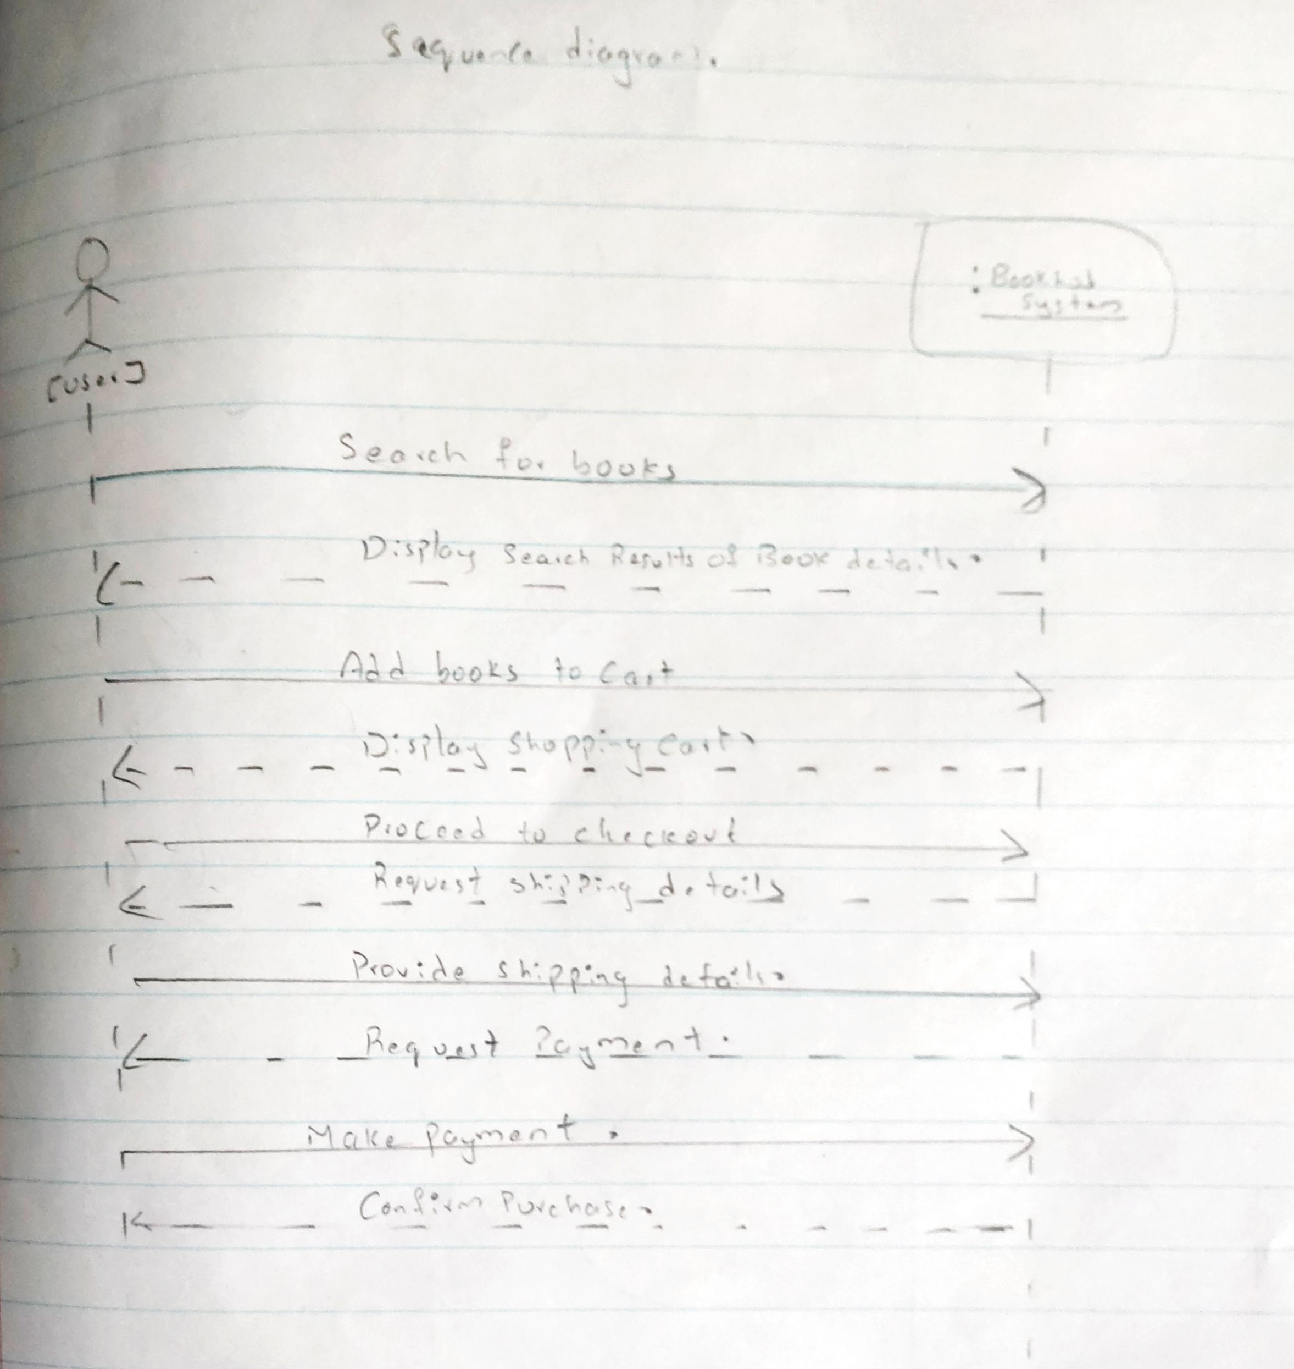

Model : Sequence Diagram

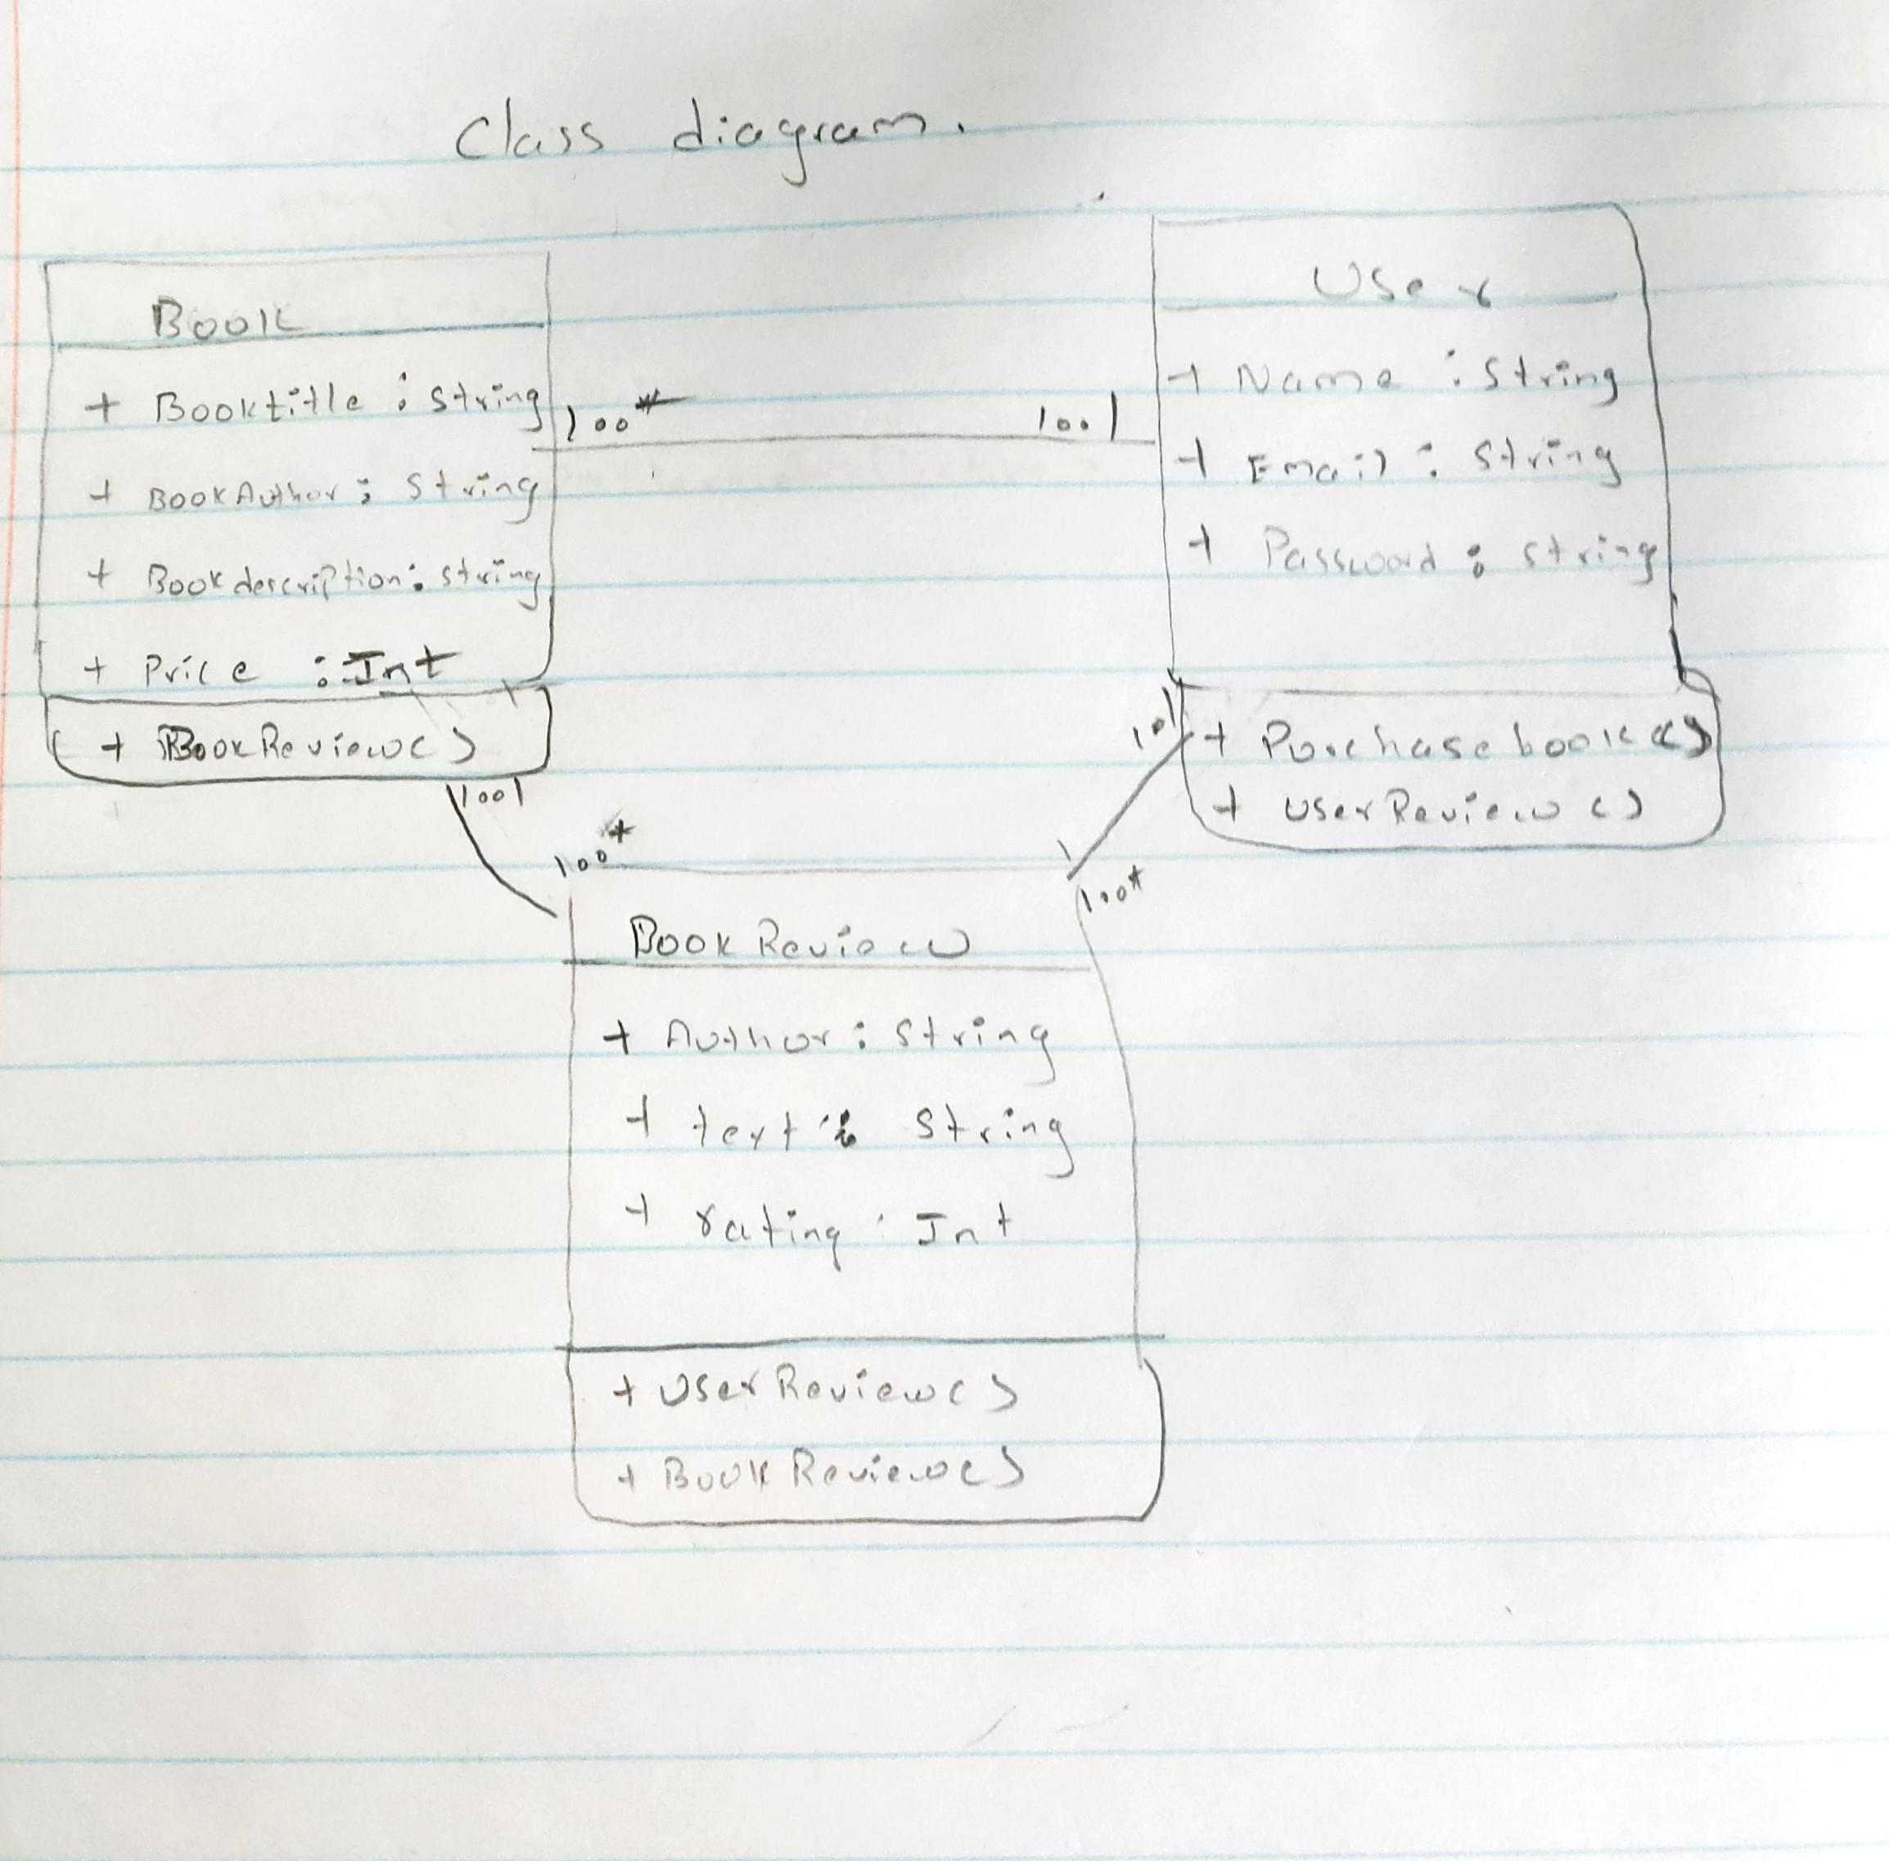

Model : Class Diagram